The following image shows denoised image with gaussian noise level 25. (U-net)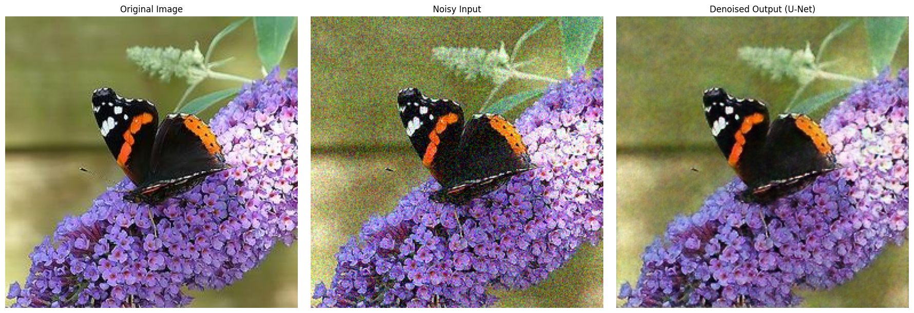

The following image shows denoised image(denoised consecutively 4 times) from gaussian noise level 90. (U-net)  
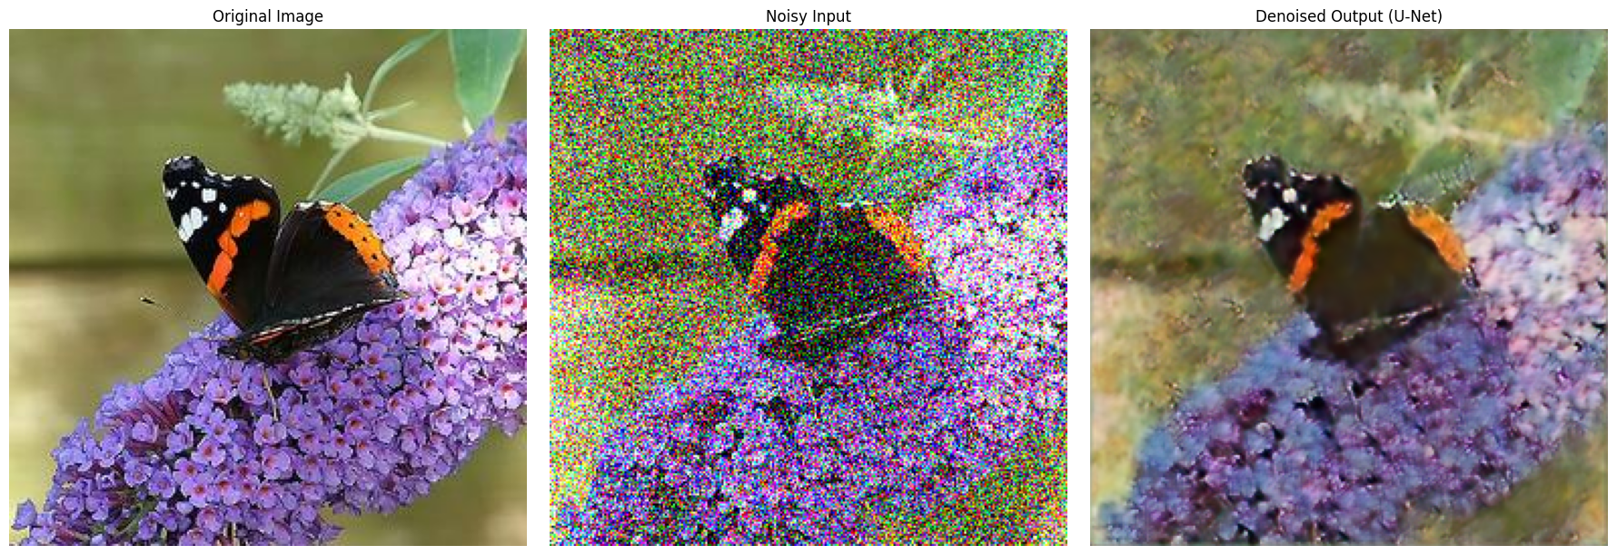

The following shows the output of previous simple CNN model, from gaussian noise level 25.

